
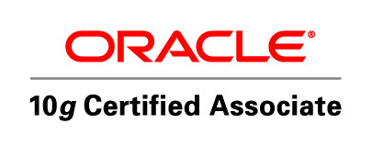
Eng/Osama Abd Elfattah Abd Elhalim Ahmed
Oracle Developer
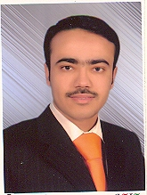

Address: 13 Elhorrya st., Hadayek El- maadi, Cairo, Egypt.
Phone number: 0225235723.
Mobile: +2 0185787415.
Email: Eng_osama_01@yahoo.com.

CAREER OBJECTIVE:-

I am seeking a position with a reputable organization in the field of:-
Software Development (ORACLE) that enables me to further develop and become
An active participant in the organization Success which is capable of enhancing my career.

EDUACTION :-

B.Sc of Electronic Engineering 2006.
University: Menoufya.
Faculty: Electronic Engineering.
Department: Computer Engineering.
Graduation Project: Human resource Database management system by oracle.
Project Grade: Excellent.
Technical skills
- Oracle 10g Developer :-

- Oracle Database 10g: Introduction to SQL.

- Oracle Database 10g: Program with PL/SQL.

- Oracle Forms Developer 10g: Build Internet Applications.

- Oracle Reports.

- Course Cisco certified network associate (CCNA ) "From National Telecommunication Institute 'NTI' " containing :-

- Network Fundamentals.

- Routing Protocols and Concepts.

- LAN Switching and Wireless.

- Accessing the Wan.

- Introduction and advanced course about network + CCNA.

- Microsoft (Windows – Word – Power point – Excel).

Database Management Systems DBMS :-

- Oracle systems.

- Microsoft access.

Courses
- Oracle Developer. ›› course
(Sql - pl/Sql – forms - reports).

- CCNA (Cisco Certified Network Associate) » course.

- Britany Languages and Computer.
5 levels in general English (conversation, grammar).

- 2006 - Oracle 6i (Sql - pl/Sql – forms - reports).

Certifications :-

- Oracle Developer (OCA) Oracle Certified Associate.
- Oracle Developer (OCP) Oracle Certified Professional.
- International Computer Driving License (ICDL).
- Cisco Certified Network Associate (CCNA) from ' NTI '.

personal skills :-

- Team working.
- Ability to learn any thing that supports my work and
Improves my skills
- Self Motivated.
- Good Communication Skills & Self Confident.

Language Skills | Arabic(mother tongue)  English » (very good » writing & speaking).
Personal details
Nationality.  Gender.  Marital status.  Date of Birth.  Military status. | Egyptian.  Male.  Single.  10 January 1983.  Finished.

- References available upon request

