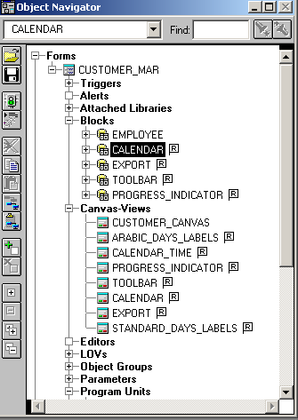

While executing form which is simply a table based blocked , im getting this screen where as layout shows as desired.

