How to Attach the CALENDAR object to your Oracle form

- Download/Save the TWO files “calendar.pll” and “stndrd20.olb” to your disk
- OPEN the PL/SQL Library calendar.pll in your Object Navigator. Point to PL/SQL Libraries Root and then go to FILE→ OPEN → Select the Library
- OPEN the Object Library stndrd20.olb in your Object Navigator. Point to Object Libraries Root and then go to FILE→ OPEN → Select the Library
- Select the FORM Node in the Object Navigator. GO to TOOLS→ Object Library → COMPONENT TAB
- Follow the Print Screen below in order

STEP 1
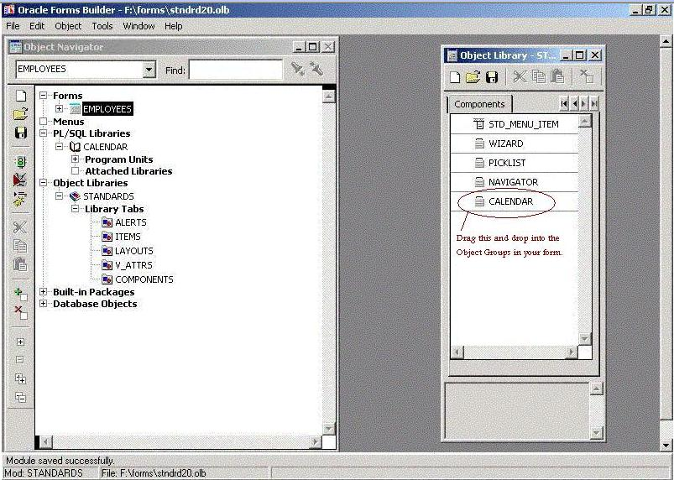
STEP 2
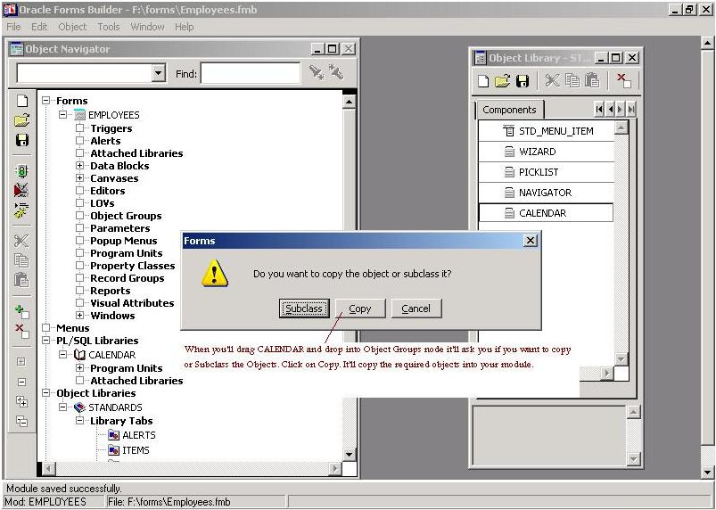

STEP 3
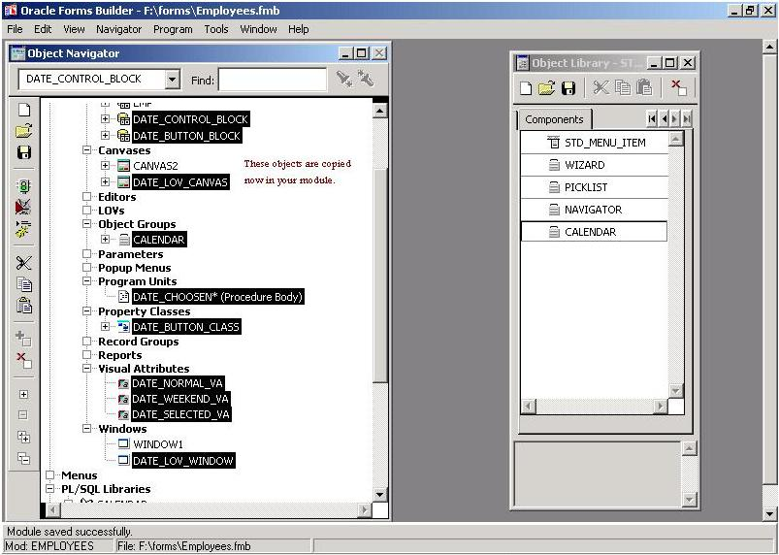
STEP4
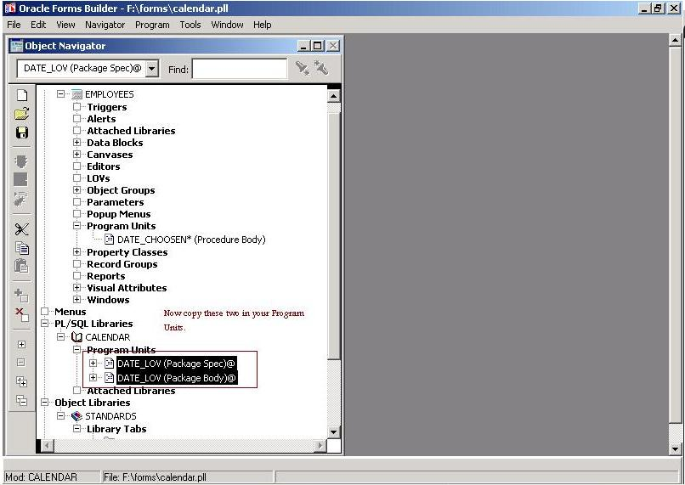
STEP 5
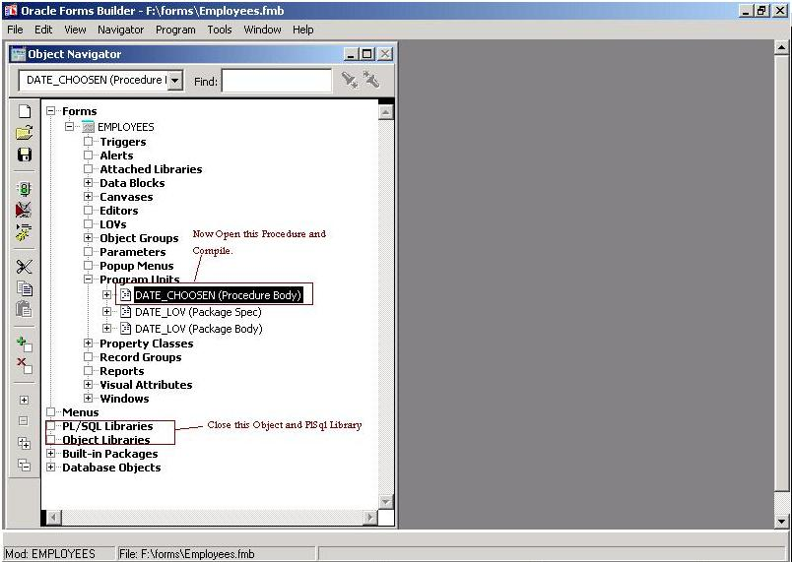
STEP 6
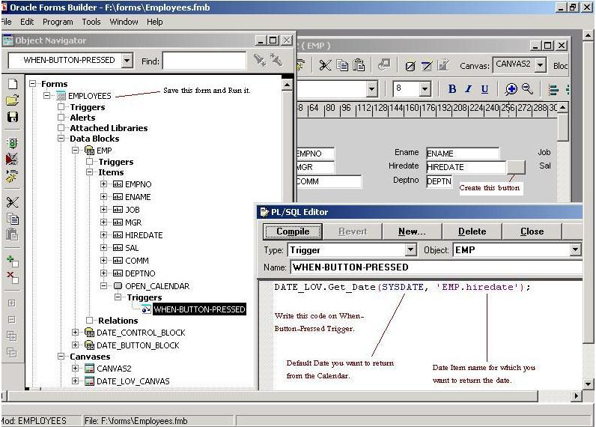

STEP 7
