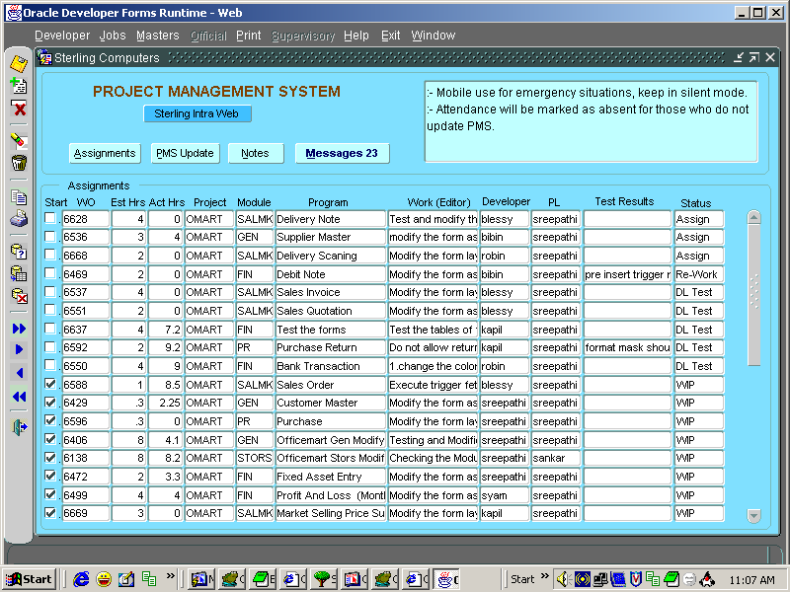

Pic1. Main screen of my 9i application.

I can exit from the application by clicking on the exit menu.
Now when I click exit, My application gets closed.
But the IE window ( in pic2—page2) is not closed.

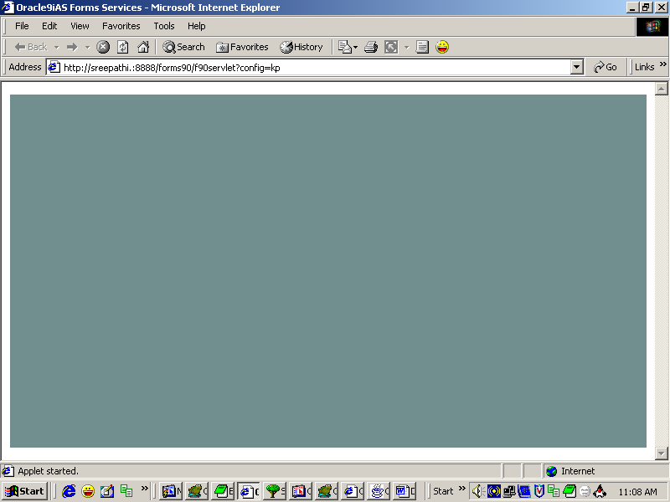

Pic2. I.E. Screen through which I am opening my application.

I want to close this window also, when I click on the exit menu.
In the picture1.

