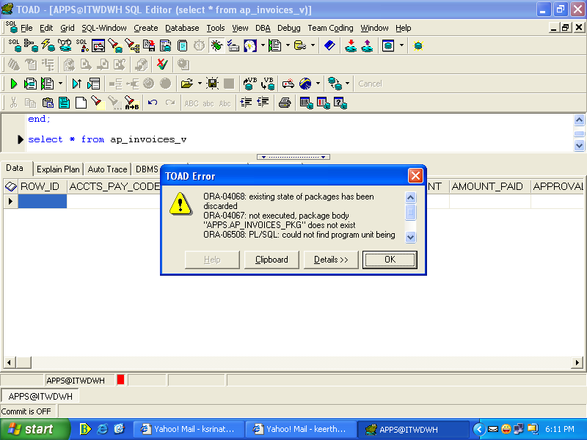

FUNCTION get_approval_status(l_invoice_id IN NUMBER,
l_invoice_amount IN NUMBER,
l_payment_status_flag IN VARCHAR2,
l_invoice_type_lookup_code IN VARCHAR2)
return VARCHAR2;

