Log on to system administrator

N: Security→Responsibility→Define

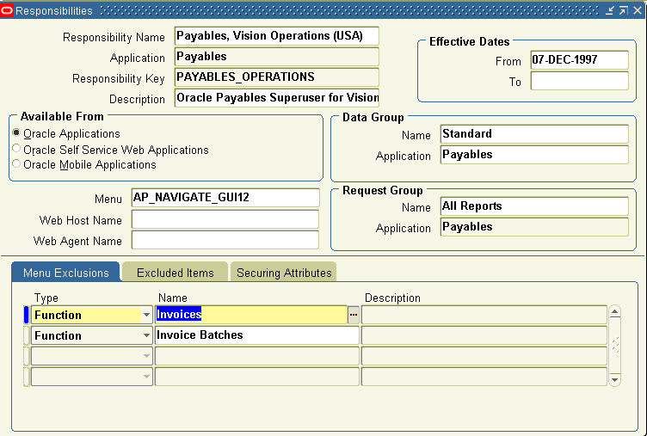
Here u can excluse whatever u want

SAVE

Now assign this responsibility to desired user

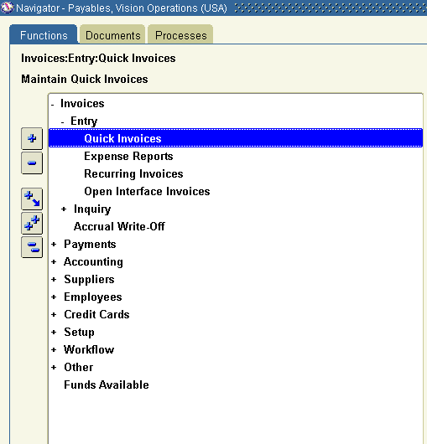

Now Invoices and Invoice batches not appearing .

