Which indexes (local or global?) to choose as a best option for below scenario?
PXCREATEDATETIME column having DATE (datatype)
partition by range (PXCREATEDATETIME)
PXCREATEDATETIME partitioned column for both tables PC_LINK_ATTACHMENT and PC_LINK_ATTACHMENT_2 table, however where clause not using the partitioned column.
PC_LINK_ATTACHMENT table with global non partitioned indexes
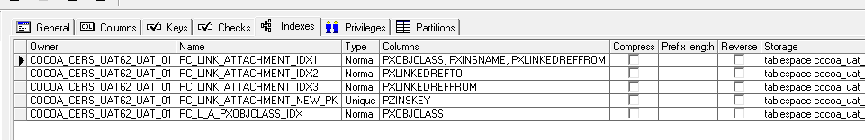

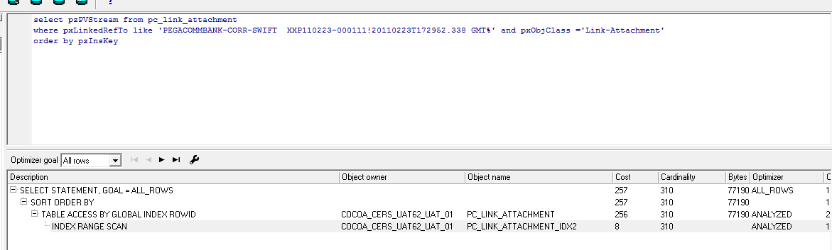

PC_LINK_ATTACHMENT_2 table with local indexes

