Oracle Whitepaper - Extending Oracle EBusiness Suite with Mobility Solutions

Fujitsu Consulting India Private Limited

Vishal Goyal

Abstract: Oracle eBusiness Suite (eBS) has always been seen and used as a back office application by most clients since last 10-15 years. It has been seen as an application which has a dull UI and is used primarily sitting in office space on one’s personal desktop or laptop without any on the go usability.
In today’s complex business scenarios, everyone is on the move. Client wants to be able to perform his actions from anywhere and whenever he wants to with an easy to use interface.
This is where extending the Oracle eBS using mobile applications really adds value. There are 2 ways to handle this and the paper discusses in detail on the same so that one can make a decision on which one to use and in which scenarios.
Oracle has released standard mobile applications across different modules which will help business user perform multiple functionalities no matter where one is.
Most of these applications come without need of any additional licenses, which means no additional cost to clients.
Oracle eBS mobile apps use role-based access control to protect mobile app data from unauthorized access. Most mobile apps have app-specific access roles. Only users who are assigned those app-specific roles can access the corresponding mobile apps.
In addition to the standard mobile apps, custom hybrid mobile apps across different modules can be built with relative ease using the Fusion Middleware SOA architecture.

Keywords: Mobile Apps, Oracle eBS, Digital Signature

1. Preface
In today’s complex business scenarios, client users want to be able to perform their actions anytime, anywhere with relative ease and easy to use interface. Accessing Oracle eBS from laptop or a desktop interface is something which most users hate to perform routine and simple tasks like checking requisition or purchase order details, approving or rejecting a workflow etc. There is a need to develop and provide these functionalities through mobile apps which can be installed with ease on ios and android platforms and configured to provide these functionalities. There are 2 approaches to this issue – 1) Use standard mobile apps available from Oracle for different functionalities or 2) Build custom mobile apps as per client requirements to accommodate multiple functions within the same app. Any of these approaches can be used depending on client needs, budget and resources availability. It is important to review both approaches with client users and understand the distinctive advantages and disadvantages in using any of these approaches. We have looked at and worked on both these approaches.

2. Standard Oracle Mobile Apps
Oracle has released standard mobile applications which are available on ios platform and most of these are being released for android platform. These applications are compatible from eBS version 12.1.3 onwards and will need additional patches to be applied to the oracle instance and configuration to be done as per standard documentation available from Oracle. Also currently, only English language is supported for all of these mobile apps.
2.1 List of Mobile Apps
Below is list of mobile apps available from Oracle. Oracle may have released more after this document was released
- Oracle Mobile Approvals
- Oracle Mobile iProcurement
- Oracle Mobile Procurement
- Oracle Fusion Expenses
- Oracle Mobile Project Manager
- Oracle Mobile Discrete Production Supervisor
- Oracle Mobile Inventory
- Oracle Mobile Maintenance
- Oracle Mobile Sales Orders
Oracle documentation is available to understand the patches required, configurations to be done, known issues if any and functionality offered by each of them. This is a very fast and cost effective approach to go mobile with Oracle eBS functionalities. Since Oracle eBS is typically hosted inside client network, mobile devices will need VPN configuration to connect to the mobile apps. It is important that you review this with your client network team before going ahead with this approach as some clients may not provide VPN connections to all business users. I will discuss in detail 4 of these mobile apps where I have worked on them and implemented 2 of these already and others are in the process of being implemented.
2.1.1 Oracle Mobile iProcurement and Procurement
I have successfully implemented these 2 mobile apps for one of our strategic clients, 1st time Fujitsu has implemented these apps anywhere. While iProcurement helps view requisition details, Procurement is used for checking purchase order details.
These 2 apps provide lot of functionalities in a very easy to use interface and will be big help to improve the productivity of the business users. Assume a purchasing officer having lunch outside office and gets an urgent call from his boss to inquire details about a particular order and asking him to call supplier to give heads up on items required on priority. In a typical scenario, purchasing officer will have to rush to his office, connect to his desktop / laptop, login to Oracle eBS, navigate to the required purchase order, note down the details and key in and dial the supplier phone number. Total processing time for this would be around 10-15 minutes. Now, with the mobile app available, all he will do is login to the app, search for this PO and have all details ready. To call supplier, he just clicks a button. Total time to do all this will be 2-3 minutes. And that too without leaving his lunch. That’s a huge productivity gain. These 2 mobile apps provide following functionalities
- Track purchase orders and requisitions and drill into details
- Search purchase orders based on key attributes (supplier, item, requestor, buyer, dates, etc.)
- View purchase order, approvers, lines, shipments, distribution and requester details
- Monitor alerts for shipment delays
- Collaborate in transaction context using device features like email, phone, and text
- Save contacts directly into your phone.
Both the apps are integrated with Oracle HRMS to pull in employee and contact details. Figure 1 show the home page dashboard for a particular user when he logs in on Procurement mobile app.
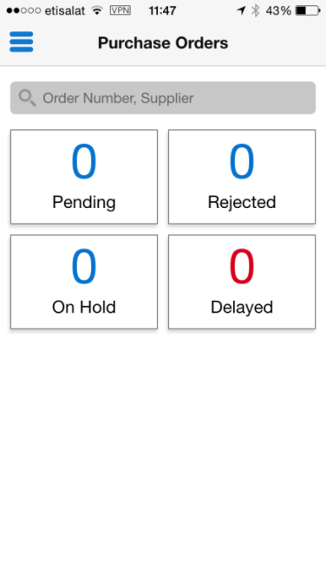
Figure 1 – Procurement Mobile App
2.1.2 Oracle Mobile Approvals
This app allows acting on workflows related to requisitions, purchase orders, expense sheets and irecruitment. One can see all pending approvals and also check the past approvals. Past approvals functionality is an absolute beauty. Many a times, after manager has acted on a workflow (approved or rejected), he is asked a question to check and confirm if he cleared a workflow for a particular purchase order or a requisition. And there is no easy way to do this in Oracle sitting on a desktop. With the mobile app, one can search the same easily and check all the details.
All active workflows are shown in one single window under Pending Approvals with options to reject, approve or request for more information. Currently, most of these workflow actions are done using emails. Oracle eBS is configured to send emails to all workflow approvers and they take required actions. This is putting tremendous load on the mail server and also makes it difficult for the mail owner to track emails and find out which ones he acted on and which are still pending. With this mobile app, no emails are required and everything happens using a very user friendly interface with complete audit trail. Figure 1 shows the home springboard on the left and the pending workflows on the right.
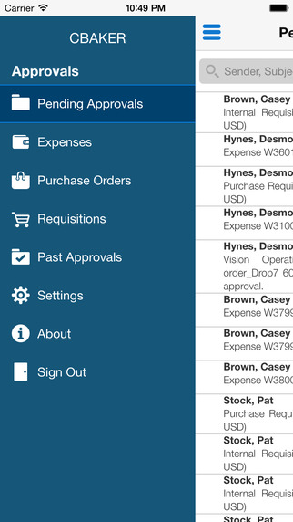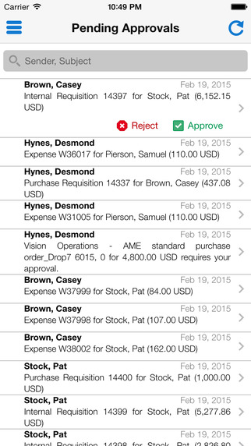
Figure 2 – Mobile Approvals

2.1.3 Oracle Fusion Expenses
How many times have you incurred expenses, taken a receipt and lost it. Even if you had the receipt, it has faded in color and is barely readable. This is a monetary loss to an individual and causes lot of discomfort.
We have looked at the Oracle Fusion expenses mobile app which empowers users to quickly capture their expenses as they are incurred with minimal data entry. It is easy to configure, requires minimal effort to implement and provides an easy to use interface to create an expense sheet with required attachment in just a few minutes.
Figure 3 below shows screens from the test we did for our client. Once submitted, this create a regular expense sheet in Oracle eBS.
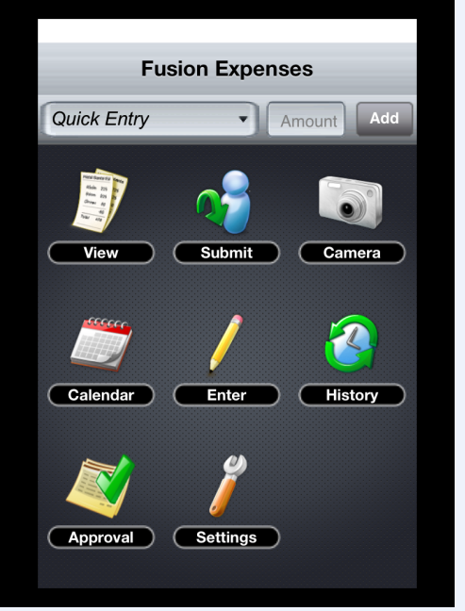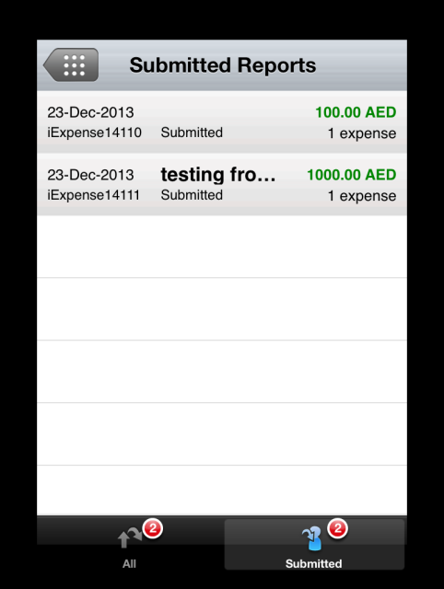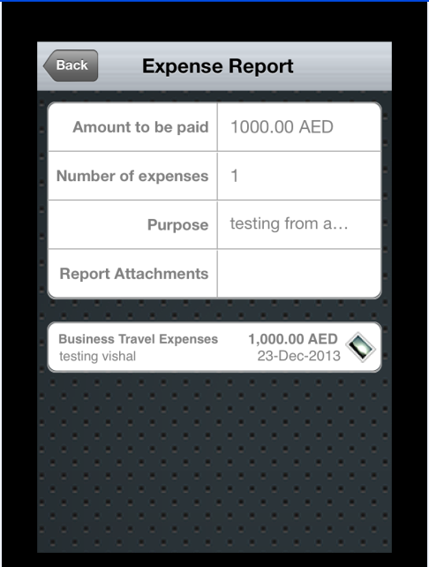
Figure 3 – Fusion Expenses

3. Custom Mobile Apps
While Oracle standard mobile apps are a fast and quick way to go mobile, it has its own disadvantages
- User has to use different mobiles apps and enter his password multiple times for each function he wants to perform.
- Mobile apps are not available to perform all functions.
- These mobile apps cannot be customized in any way Wrt branding or adding new functionalities.
- Attachments are not visible from any of these apps.
To overcome these limitations and provide a personalized view of the mobile app for each client, we worked on a solution to build custom mobile apps and integrate different business functions into the same app. This approach provides us the option to do anything we need to as per client needs.
- We used the standard oracle architecture to use Integrated SOA gateway REST web services to expose the functionalities from Oracle eBS and consuming the same in Mobile Apps.
- We created an app to include following functions
  - Authenticate login to app with username and password.
  - Leave Balance check from Oracle HRMS for all types of leaves defined in the system.
  - Submitting Leave application in Oracle HRMS.
  - Approving / rejecting leaves based on supervisor hierarchy.
  - Ability to check pay slip as per setup defined in Oracle HRMS.
  - Ability to approve / reject Purchase Orders, view attachments and check history.
  - Ability to approve / reject Requisition, view attachments and check history.
Figure 3 below shows some of the snapshots from the mobile app.
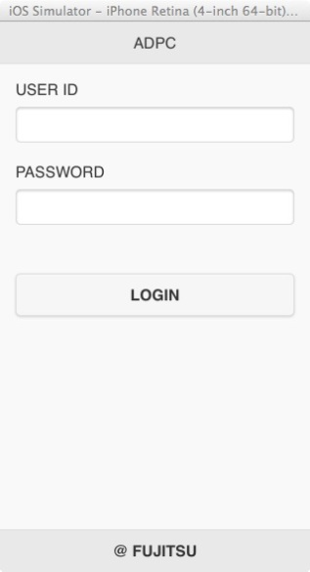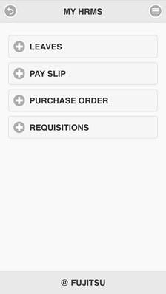
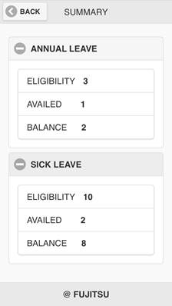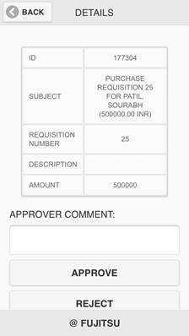
Figure 4 – Custom eBS Mobile

3.1 Digital Signature Capture
Many a times, especially in a government organization, we have seen need to have digital signature captured for the person who is acting on the workflow because of statutory needs. We looked at this requirement and implemented the same in one of the mobile apps we built for Siebel CRM for workflow approvals.
Mobile app provides an interface to digitally sign the workflow before approving or rejecting the same. The signature gets stored in the application against the transaction and can be retrieved whenever required. This helps reduce carbon footprint by avoiding printing the form, getting it signed and then uploading it to application.
Below shows actual screen shot from the Siebel CRM mobile app which has been built for one of our clients and is being used by CEO and EXCOM. The same functionality can be integrated into the Oracle eBS mobile app for each and every workflow.
This really adds value to the mobile app by giving it a very personal feel.
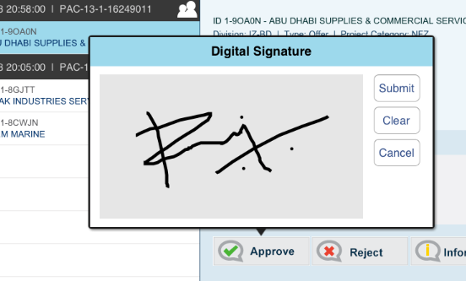
Figure 5 – Digital Signature
Margin: Bottom 25mm
4. Conclusion
In today’s Internet of things (IoT) world, everyone is connected to smart phones no matter where they are - stuck in traffic jam, attending meeting, travelling on vacation with kids, in hospital for a medical emergency, waiting at airport for a flight to catch etc.
Margin: Bottom 25mm

It becomes very important that business users are able to perform most of their tasks no matter where they are with relative ease with click of few buttons. This helps improve the cycle time there by increasing efficiency of the entire business process.
Extending your Oracle eBusiness Suite with Mobility Solutions is a real value add to business users and something which will happen all across clients sooner or later. It is important that we have complete understanding of the options available for achieving this goal, which approach will work where and are able to add real value to our customers in quick time.

Reference
[1] Oracle E-Business Suite Mobile Apps, Release 12.1 and 12.2 Documentation (Doc ID 1641772.1)

