We have installed Oracle 8i (8.1.7.0) database on a PC of win 2K.

The host name of this PC : LTC-1
IP of this PC : 192.168.140.151

Database SID : ORATEST

We have installed this on C drive.

We have tried to connect this database from another PC, we are able connect this database.

Now we have also installed Oracle 9iAS release 1 (Version 1.0.2.0.0) on the same PC of D drive

The steps performed and the parameters given by us are:

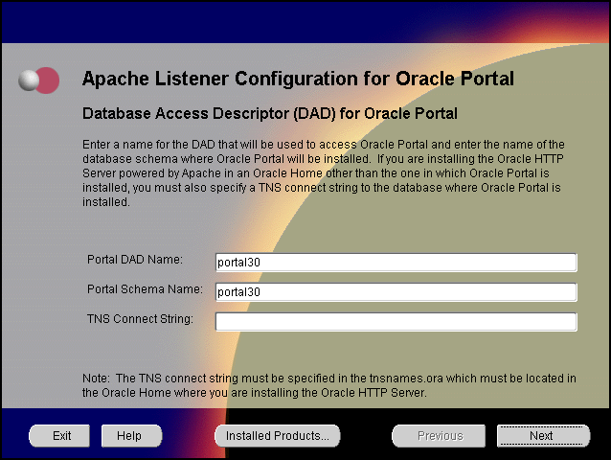

Portal DAD Name: portal30
Portal Schema Name: portal30
TNS Connect String: intradev

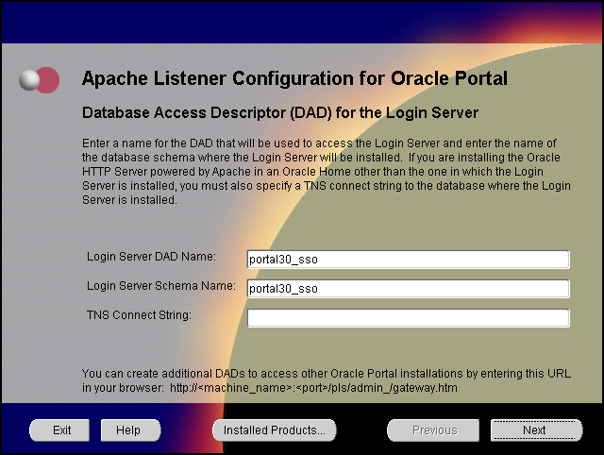

Login Server DAD Name: portal30_sso
Login Server Schema Name: portal30_sso
TNS Connect String: intradev

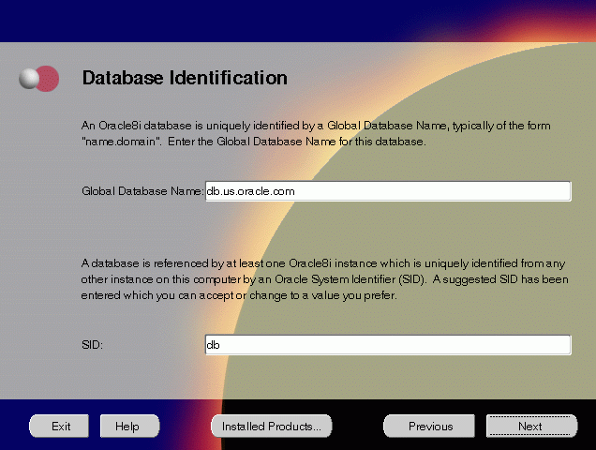

Global Database Name: ORA9I
SID:ORA9I

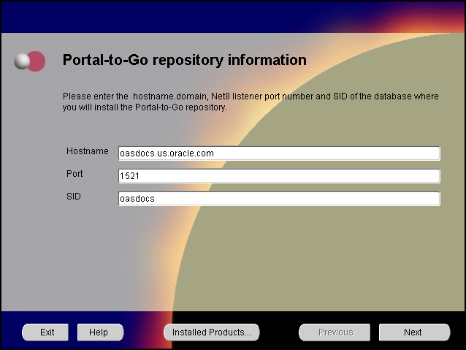Hostname: 192.168.140.151
Port: 1521
SID: oratest
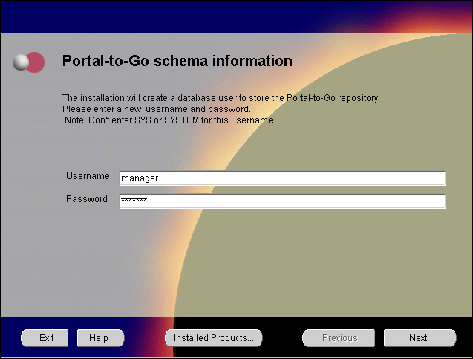

Username: manager
Password: manager

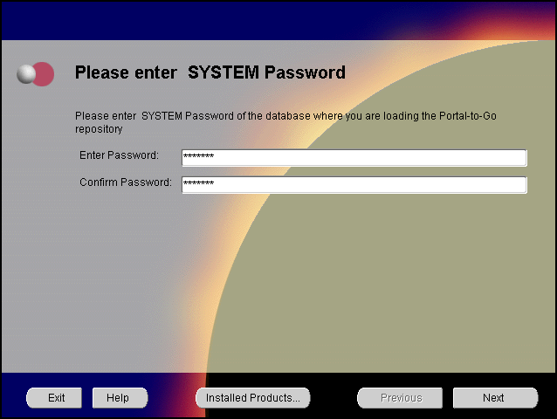

Enter Password: manager
Confirm Password: manager

The following services are created and started by default after the installation of 8i & 9i database with AS

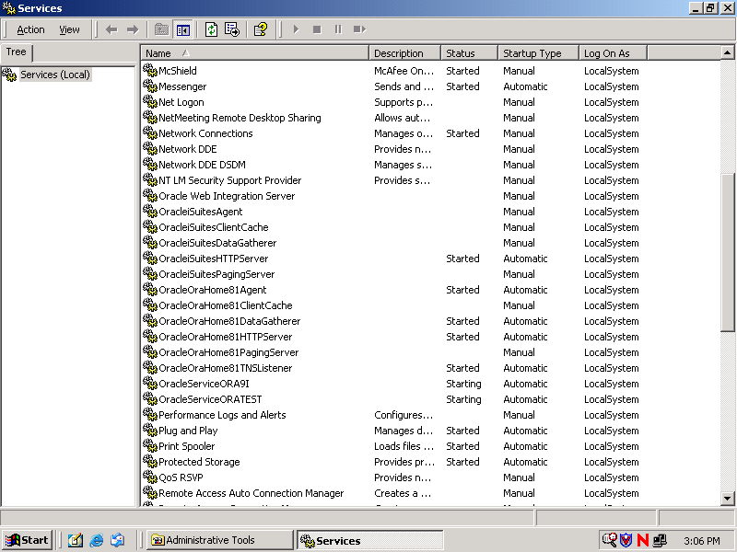

Registry file is also attached along this.

After this we have installed Administrative and Development Client.

We have done the following
To load the bootstrap repository in the Oracle Portal-to-Go schema:
- Open a DOS session, and go to ORACLE_HOME\panama\setupconf directory.
- Type the following command:
- Set JAVA_HOME=ORACLE_HOME\Apache\jdk

- Type the following to run the batch files:
- pa_java_inst

While configuring the Web Integration Server:
- Run the Web Integration Server. - OK
Web Integration Server is installed as a service. Select Oracle Web Integration Server from the Services dialog, and click the Start button.
- From a browser, go to the Web Integration Server URL:
http://host_name.domain:5555
We have entered the URL as http://192.168.140.151:5555
Page can not be displayed
Then we entered the URL as http://192.168.140.151:80
We could connect Oracle HTTP server page
- Log in to the Web Integration Server with the user name Administrator, and password manage, which is the default password. –Cannot connect
- Select Settings. The server settings appear. Click Edit.
- Enter the Proxy (HTTP) and Secure Proxy (HTTPS) settings for your environment.
- Click Submit.
Click Logout.
Then we performed following steps:
- Configure the httpd.conf file.
The httpd.conf file is in the ORACLE_HOME\Apache\Apache\conf directory.
Create a Personalization Portal (papz) alias. This is needed so that the application server can find the
http://hostname/papz/login.jsp.
Add a line at the end of the Alias section:
# PTG Start
Alias /papz/ "<ORACLE_HOME>\panama\server\papz\"
# PTG End

- Configure the jserv.conf file.
The jserv.conf file is in the ORACLE_HOME\Apache\Jserv\conf directory.
In the ApJServMount section, add the Oracle Portal-to-Go specific mount point:
# PTG Start
ApJServMount /ptg /root
# PTG End

- Configure the jserv.properties file.
The jserv.properties file is in the ORACLE_HOME\Apache\Jserv\conf directory.
Next to the other "wrapper.classpath" entries, add all the required Oracle Portal-to-Go files to the classpath.
# PTG Start
wrapper.classpath=<ORACLE_HOME>\panama\server\classes
wrapper.classpath=<ORACLE_HOME>\panama\lib\panama_core.zip
wrapper.classpath=<ORACLE_HOME>\panama\lib\panama_papz.zip
wrapper.classpath=<ORACLE_HOME>\panama\lib\client.zip
wrapper.classpath=<ORACLE_HOME>\panama\lib\server.zip
# PTG End

- Configure the zone.properties file.
The zone.properties file is in the
ORACLE_HOME\Apache\Jserv\servlets directory.
  - In the List of Repositories section, add the Oracle Portal-to-Go specific repository to the existing repository line with a comma (,) separator:
  - # PTG Start
  - repositories=<ORACLE_HOME>\Apache\Jserv\servlets,<ORACLE_HOME>\panama\
  - server\papz
  - # PTG End

  - In the Startup Servlets section, add the Oracle Portal-to-Go specific servlets:
  - # PTG Start
  - servlets.startup=oracle.panama.ParmImpl
  - # PTG End

  - In the Servlet Aliases section, add the Oracle Portal-to-Go specific servlets:
  - # PTG Start
  - servlet.rm.code=oracle.panama.ParmImpl
  - # PTG End
After installation, to verify that individual Oracle Portal-to-Go components are properly configured:
We have installed jinit11824.exe on the same PC
- Test the sample Java Servlet at the following URL:
http://host_name.domain/papz/test.jsp
"Hello World" should appear on the screen.
Not able to open the page ‘ The page can not be displayed ‘ appears
- Test whether the Personalization Portal is working properly by accessing the following URL:
http://host_name.domain/papz/login.jsp
The login page should appear. The Personalization Portal prompts you to enter a user name and a password. You can log in using "Administrator" as the user name and "manager" as the password.
But we get the message ‘page not found’.
- Run the Oracle Portal-to-Go Request Manager by accessing the following URL:
http://host_name.domain/ptg/rm
But we get the message ‘page not found’.

